**Assignment-UI/UX**

**AI Poem Writer(Outset)**

**Aim:**

Create an app for **generating poems** using AI.

**Platform Steps:**

1. **Collect Information**: Research types of poetry, themes, and AI text generation models.
2. **Create Canvas**: Design layout with sections for **poem generation**, **theme selection**, and **saved poems**.
3. **Add Elements**: Use aesthetic visuals, calming fonts, and intuitive controls for users to input themes or keywords.
4. **Build Features**: Implement **AI-powered poem generation**, **theme customization**, and the ability to save and share poems.
5. **Prototyping**: Develop an **interactive prototype** to test user flow and AI accuracy.

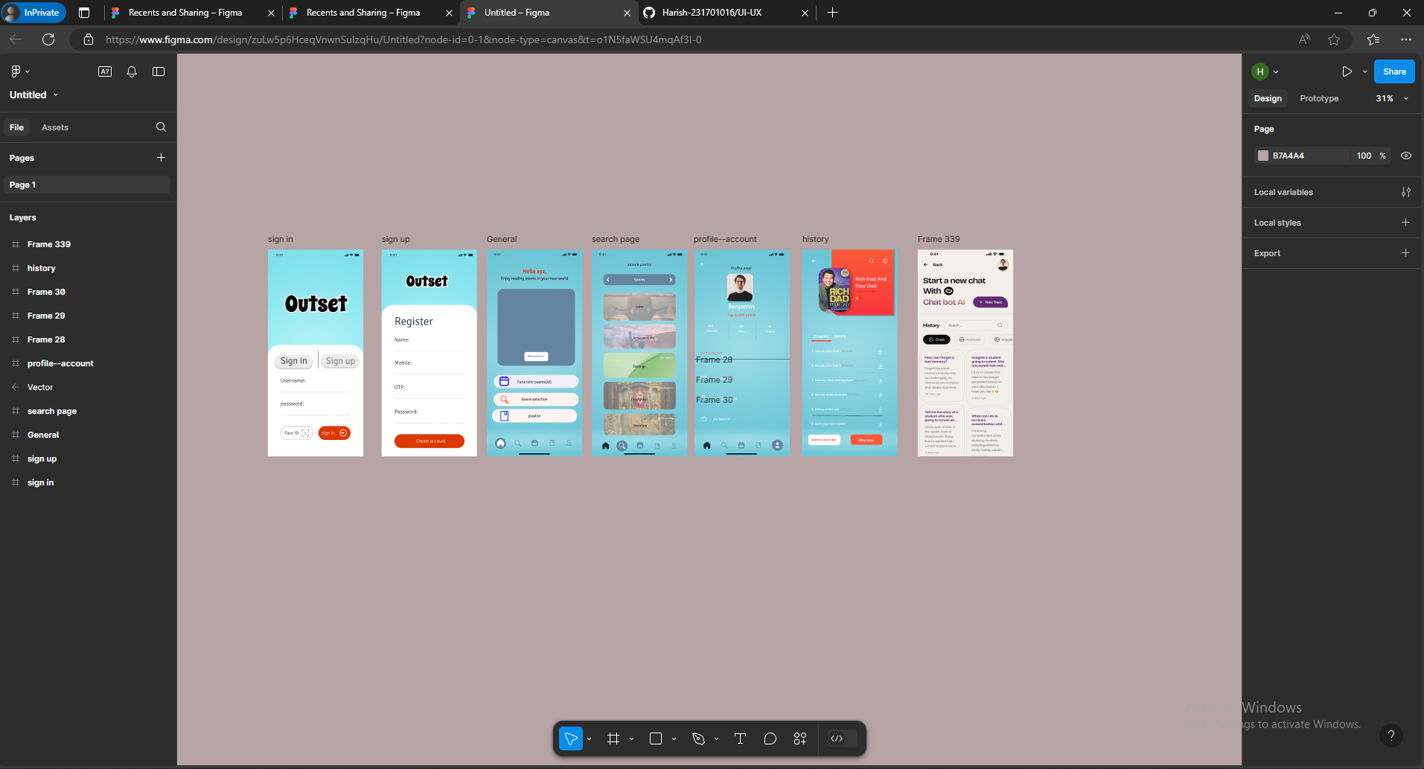

**Result:**

The **AI Poem Writer App** design is **created** and **verified**.